1 - In these pictures, what do you think each person is thinking or saying?
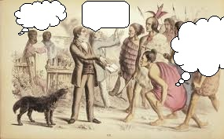
2 – Move back/move forward – what do you think just happened prior to these pictures? What do you think happened after these pictures?

